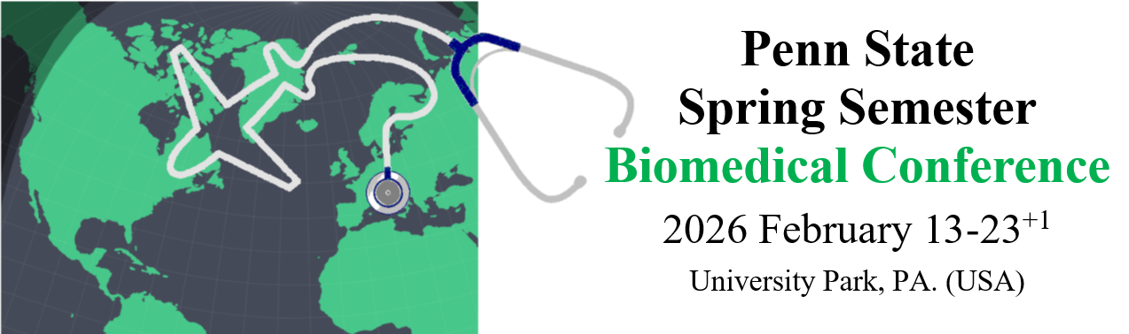Application form

Fill out the form and send your application package by email to: *marialuisa.genova@unibo.it*

**Last name**

**First name**

**Email address**

**Phone**

 +39

**Nationality and Date of birth**

**Residential address**

(City, province, street name, postal code)

**Passport number**

**Degree Course enrollment**

(EN) 9210-Medicine and Surgery, Bologna

(IT) 5709-Medicina e Chirurgia, Forlì

**Student position** (A.Y. 2025-2026)

Sophomore (Year 2)

Junior (Year 3)

Senior (Year 4)

Super Senior (Year 5+)

**Accommodation choice criteria**

1st choice 2nd choice NO

Homestay

Hotel (*with surcharge*)

**Notes, if any**

1/2

**UNIBO registration number**

(ID, matricola)

**Issued by**

**Expiration date**

(IT) 5905-Medicina e Chirurgia, Forlì

Motivation

2/2

Date and legible signature of the candidate

INFORMATION ON DATA PROTECTION - The data provided will be processed to the extent strictly necessary and for the purposes related to the registration and conduct of the Biomedical Conference. In particular, the data provided will be processed for the verification of existence of the requisites required for the participation in the selection procedure, in such a way as to guarantee its security and protect the confidentiality of the interested party. Any refusal to provide personal data implies the impossibility for the Data Manager of proceeding with the registration of the candidate in the selection procedure.

DM: Maria Luisa Genova

**What will make you a great Biomedical Conference participant?**

Give us a sense of the kind of person you are, and how you see yourself. Let us learn about your strengths and weaknesses, aims, goals, values, and more.

Highlight your personality in a traditional written essay (up to 500 words in the box below) or submit a video essay or infographics of your choice as a separate file/shareable link.

I hereby guarantee the financial availability and firm will to pay the cost of my travel package at the time of confirmation of admission to the Biomedical Conference, according to the terms indicated by the Organizers.

Please upload a passport-style headshot photograph

HERE